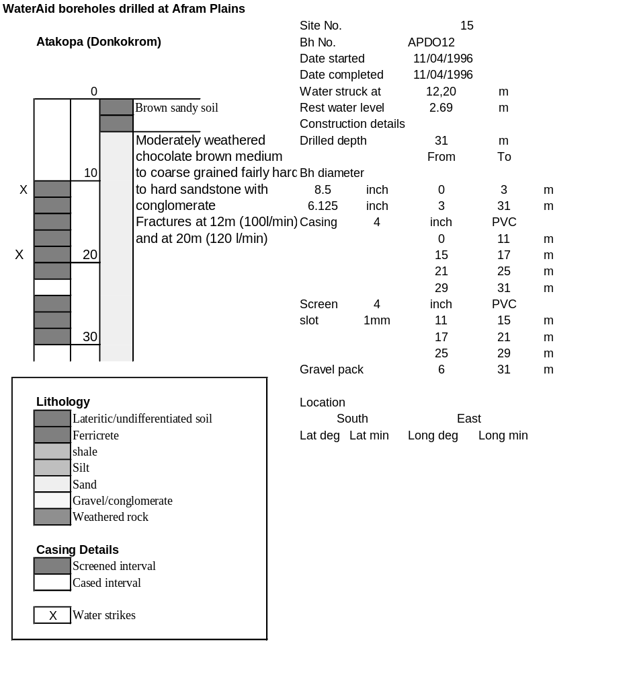

Ghana | Test pumping
Borehole No. |  | APDO12
Hole No |  | 15
Village |  | Atakora-Donkokrum
Date |  | 17/04/1996
Point above GL |  | 0.5 | m
Pump depth |  | 23 | m
SWL |  | 3.19 | m
Start Time |  | 11:55
Drawdown test |  |  |  |  | Recovery test
time | pwl (m) | Q l/min | dd | sc | Time | wl (m) | s' | t/t'
0.00 | 3.19 | 100.00 | 0.00 |  | 0.00 | 6.44 | 3.25
1.00 | 4.96 | 100.00 | 1.77 | 56.50 | 1.00 | 4.59 | 1.40 | 181.00
2.00 | 5.13 | 100.00 | 1.94 | 51.55 | 2.00 | 4.40 | 1.21 | 91.00
3.00 | 5.24 | 100.00 | 2.05 | 48.78 | 3.00 | 4.30 | 1.11 | 61.00
4.00 | 5.31 | 100.00 | 2.12 | 47.17 | 4.00 | 4.22 | 1.03 | 46.00
5.00 | 5.38 | 100.00 | 2.19 | 45.66 | 5.00 | 4.17 | 0.98 | 37.00
6.00 | 5.43 | 100.00 | 2.24 | 44.64 | 6.00 | 4.12 | 0.93 | 31.00
7.00 | 5.46 | 100.00 | 2.27 | 44.05 | 7.00 | 4.08 | 0.89 | 26.71
8.00 | 5.49 | 100.00 | 2.30 | 43.48 | 8.00 | 4.05 | 0.86 | 23.50
9.00 | 5.53 | 100.00 | 2.34 | 42.74 | 9.00 | 4.02 | 0.83 | 21.00
10.00 | 5.54 | 100.00 | 2.35 | 42.55 | 10.00 | 4.00 | 0.81 | 19.00
11.00 | 5.57 | 100.00 | 2.38 | 42.02 | 12.00 | 3.94 | 0.75 | 16.00
12.00 | 5.59 | 100.00 | 2.40 | 41.67 | 14.00 | 3.90 | 0.71 | 13.86
13.00 | 5.65 | 120.00 | 2.46 | 48.78 | 16.00 | 3.87 | 0.68 | 12.25
14.00 | 5.67 | 120.00 | 2.48 | 48.39 | 18.00 | 3.84 | 0.65 | 11.00
15.00 | 5.71 | 120.00 | 2.52 | 47.62 | 20.00 | 3.82 | 0.63 | 10.00
16.00 | 5.73 | 120.00 | 2.54 | 47.24 | 22.00 | 3.79 | 0.60 | 9.18
17.00 | 5.78 | 120.00 | 2.59 | 46.33 | 24.00 | 3.78 | 0.59 | 8.50
18.00 | 5.80 | 120.00 | 2.61 | 45.98 | 26.00 | 3.76 | 0.57 | 7.92
19.00 | 5.82 | 120.00 | 2.63 | 45.63 | 28.00 | 3.74 | 0.55 | 7.43
20.00 | 5.83 | 120.00 | 2.64 | 45.45 | 30.00 | 3.73 | 0.54 | 7.00
22.00 | 5.88 | 120.00 | 2.69 | 44.61 | 35.00 | 3.70 | 0.51 | 6.14
24.00 | 5.90 | 120.00 | 2.71 | 44.28 | 40.00 | 3.67 | 0.48 | 5.50
26.00 | 5.91 | 120.00 | 2.72 | 44.12 | 45.00 | 3.65 | 0.46 | 5.00
28.00 | 5.93 | 120.00 | 2.74 | 43.80 | 50.00 | 3.63 | 0.44 | 4.60
30.00 | 5.96 | 120.00 | 2.77 | 43.32 | 60.00 | 3.60 | 0.41 | 4.00
35.00 | 5.99 | 120.00 | 2.80 | 42.86 | 70.00 | 3.57 | 0.38 | 3.57
40.00 | 6.03 | 120.00 | 2.84 | 42.25 | 80.00 | 3.55 | 0.36 | 3.25
45.00 | 6.07 | 120.00 | 2.88 | 41.67 | 90.00 | 3.54 | 0.35 | 3.00
50.00 | 6.10 | 120.00 | 2.91 | 41.24 | 100.00 | 3.52 | 0.33 | 2.80
55.00 | 6.14 | 120.00 | 2.95 | 40.68 | 110.00 | 3.51 | 0.32 | 2.64
60.00 | 6.15 | 120.00 | 2.96 | 40.54 | 120.00 | 3.50 | 0.31 | 2.50
70.00 | 6.19 | 120.00 | 3.00 | 40.00
80.00 | 6.23 | 120.00 | 3.04 | 39.47
90.00 | 6.26 | 120.00 | 3.07 | 39.09
100.00 | 6.29 | 120.00 | 3.10 | 38.71
110.00 | 6.31 | 120.00 | 3.12 | 38.46
120.00 | 6.35 | 120.00 | 3.16 | 37.97
130.00 | 6.38 | 120.00 | 3.19 | 37.62
140.00 | 6.41 | 120.00 | 3.22 | 37.27
160.00 | 6.42 | 120.00 | 3.23 | 37.15
180.00 | 6.44 | 120.00 | 3.25 | 36.92

